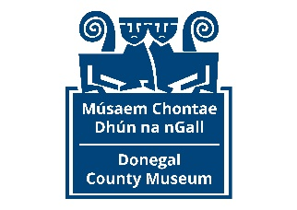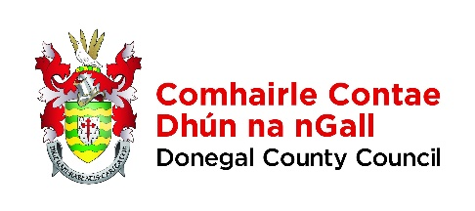
Commemorations Programme 2024 – Women 100
Open call for Artists

The Commemorations Programme, Culture Division, Donegal County Council is supported by the Department of Tourism, Culture, Arts, Gaeltacht, Sport and Media.

1.CONTACT DETAILS

Applicant /

Address (including eircode):

Telephone/Mobile:

E-mail:

Website (if applicable):

PPS No.

_________________________________________________________________________________

2. PROFESSIONAL DETAILS

What is your artform specialty?

Relevant Educational Qualifications (i.e. Post-second level courses you have completed and the qualifications you have attained. Please outline and state the dates of same.)

Awards, Bursaries or Prizes that you have attained (Please outline and state the year in which the award was received.)

3. Please provide 2-3 examples of projects recently completed by you, which you believe may inform the way you respond to this Open Call (300-500 words.)

PROPOSED OPEN CALL PROJECT WORK PROGRAMME

4. Please describe how you plan to deliver your proposed Open Call Project. In your Description, please provide the following information –
(a.) a brief outline of your proposed Work Schedule over the period of the Open Call (end June – mid October, 2024)
(b.) an indication as to what you propose to commemorate?
(c.) an indication as to the nature of the Artwork, or series of Artworks you envisage being created during the period of the Open Call
(d.) how you propose that the Public may engage with the Artwork(s)? (max 500 words)

SUPPORTING DOCUMENTATION

5. Please supply the following documentation in support of your application -

- Current, up-to-date Curriculum Vitae.
- A selection of Work Samples that you feel best represents your practice.
- Should you wish, you may also supply additional documentation in the form of reviews of your work, media features etc. that you feel may support your submission.

Please supply supporting documentation in PDF or Jpeg formats or links to personal websites, YouTube or similar. Supporting documentation that cannot be readily accessed, however, will not be assessed as part of your submission.
__________________________________________________________________________________

COMPLETED APPLICATION FORMS / CLOSING DATE

6. Completed Application Forms, accompanied by the appropriate supporting documentation, must be submitted by Email only to E: museum@donegalcoco.ie The Closing Date for receipt of Completed Applications is 4.30pm on Monday 17th June 2024. Applications cannot be accepted after this deadline. The decision of the Open Call Selection Panel will be final.

Signed:

Date:

